**Project Name - Employments Data Analysis Tool Using MS Excel**

**Project Overview**

The purpose of this project is aimed to solve descriptive analysis (total salary, average salary, max salary, total employees) or more analysis (count of male – female, working region of employees, max salary paid in which region or department, department wise total salary) etc. report of employee dataset.

**Features of this project**

Employment management helps companies attract and retain to talent by automating and optimizing the most important HR tasks.

This project outlines the top features of an effective employee management.

Key Features.

1. Maintain employee data.
2. Data analysis of employee data.

**Technology Used**

MS Excel

ʼ

**Functions**

VLOOKUP, IF AND OR NESTED, SUMIFS, AVERAGE, MEAN, MEDIAN, COUNT, MAX, MIN, ETC.

**Employee Dataset**:

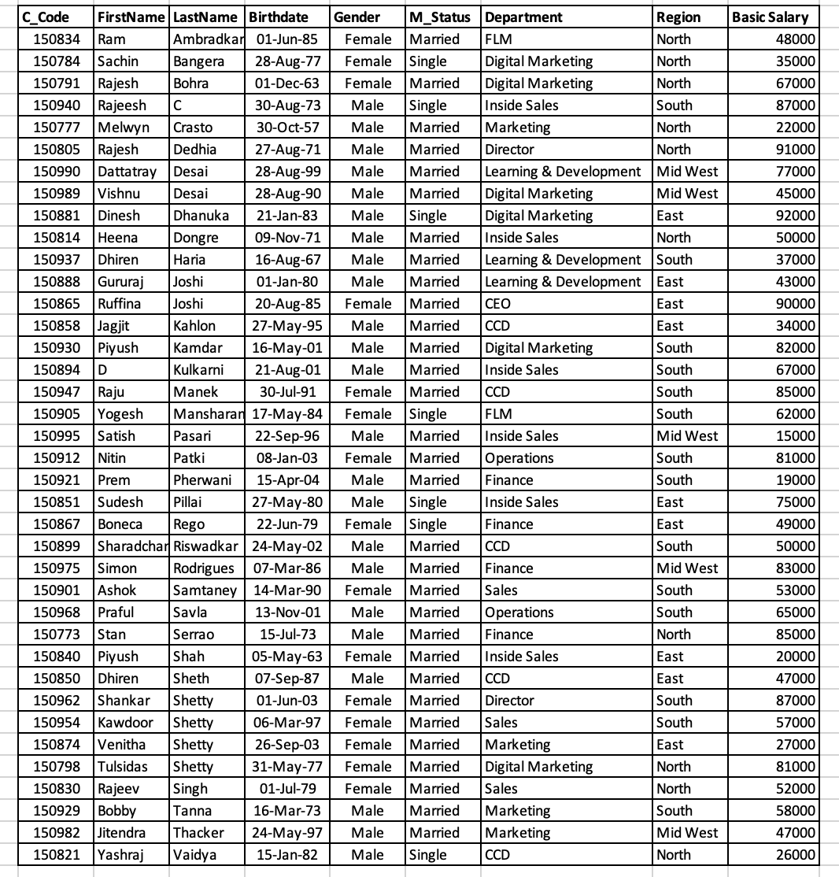

**SET- 1   
Questions for Analysis:**

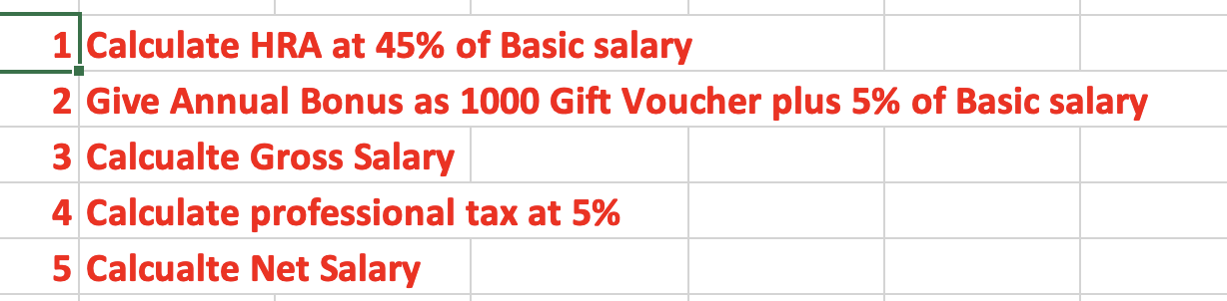

**Analysis on all these questions:**

**SET - 2**

**QUESTIONS**

**ASNWERS**

**SET – 3**

**QUESTIONS**

**ANSWERS**

**SET - 4**

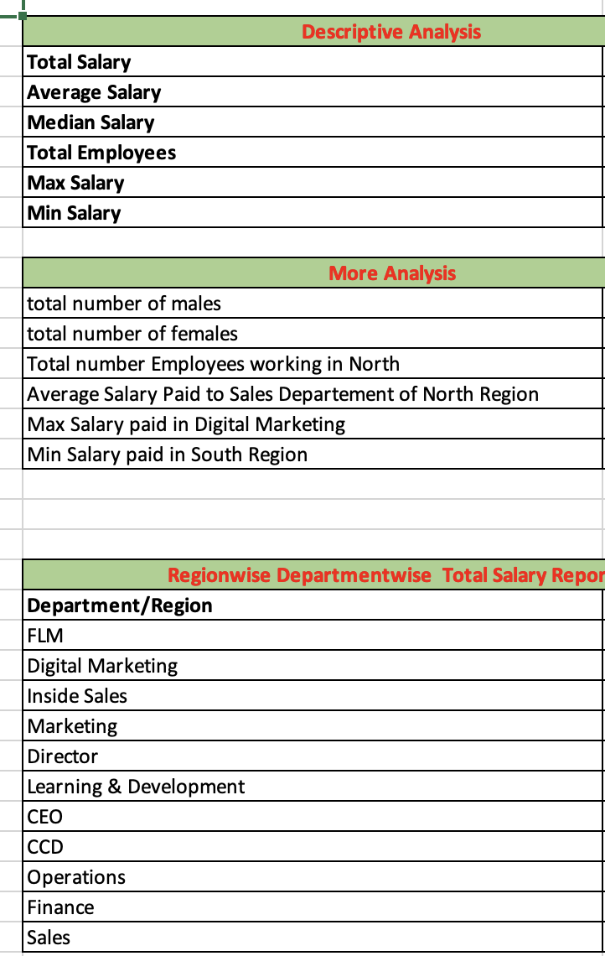

**ANSWERS**

**SET – 5**

**ANSWERS**

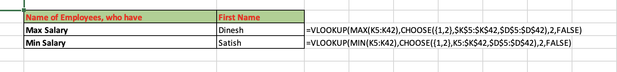

**SET – 6**

**QUESTIONS**

**ANSWERS:**

